HCI And Interactive Storytelling: Computer Science Education

HCI and Interactive Storytelling: Computer Science Education

Rayman, RS, Sarowa

Department of Computer Science, Mathematics, Physics, and Statistics, University of British Columbia, raymansarowa1@gmail.com

Although there is no distinctive header, this is the abstract. In this article, we explore interactive storytelling and how it can be used to improve computer science education for those outside of the field, meaning those who are not professionals or students. To do this, we conducted a study where we had one group read an article and another group go through an interactive created using twine. We used a quiz, and a user experience survey in order to measure the success of getting the information to the group. The results showed the interactive outperformed the non-interactive on both measures. Further results can be used to improve upon, or further test these results. All research and writing were done by Rayman Sarowa, the only group member.

Rayman Sarowa confirms sole responsibility for the following: study conception and design, data collection, analysis, and interpretation of results, and manuscript preparation

CCS CONCEPTS • Human Computer Interaction• Interactive Storytelling• Human-centered Computing

**Additional Keywords and Phrases:** Education, User Experience, Knowledge Recollection, Design

1. Introduction
   1. Problem Context and Motivation

Human computer interaction is, according to The Interaction Design Foundation, “a multidisciplinary field of study focusing on the design of computer technology, and particularly the interaction between humans (the user) and computers.” [4]. While interactive storytelling is, according to ustory.app, “a genre of storytelling that offers readers the chance to interact with the story and shape its outcomes.” [2]. A non-digital example of interactive storytelling might be a solve it yourself mystery novel since there are multiple paths the reader can choose and multiple endings they can end up at. HCI is seen as the intersection between the hard sciences and humanities as it incapsulates psychology, sociology, design, and of course, computer science. Interactive storytelling deals with psychology, as the choices the user makes are more personal than if they were experiencing a traditional story and sociology, since stories often give commentary on various sociological issues. However, what they have in common is that both deal with human interaction. Interactive storytelling is a widely studied topic in HCI, with 8980 results since 2020. Many of the papers on this topic involve the improvement of learning because storytelling can be more efficient than traditional forms of learning such memorizing facts or reading about a topic. For example, Ferriera, Nunes, and Nisi explore how interactive storytelling can be used to better educate people on the reality of climate change [1]. For another perspective, Melcer let al explore using an interactive game to teach researchers proper ethics and conduct surrounding research [5]. To further show that this can be effective, Nair and Yunus write “digital storytelling may be a highly effective teaching tool for children of all ages and grade levels who are given the responsibility of creating their own stories” [3]. They further go onto comment “It is important to offer new educational techniques based on the use of digital technology in order to foster the development of meaningful learning. Active participation and 21st-century teaching and learning are now possible thanks to modern collaborative technology, such as digital storytelling” [3]. Also, interactive storytelling and digital storytelling are two different things. Digital storytelling is just storytelling that uses digital media features such as video, digital text, etc. Our topic is the combination of digital and interactive storytelling.

The reason I chose to dive into this topic is because it is a unique topic and has a wide range of subjects. I will elaborate on what I narrowed in on later, but I found that the learning aspect of this subject would make for a good study or experiment. In this paper, I have explored the idea of HCI and Interactive storytelling in regards to learning. This was done by comparing several separate methods of learning such as interactive and non-interactive storytelling with different stories and tasks. The participants in my study have had their memories tested in regards to the separate storytelling methods and tasks. This has been done by having one group read a article relating to key topics in human computer interaction and another group going through an interactive based on those articles. This has been further elaborated on in the study design section The results of the study show us the interactive outperforms the non-interactive in terms of quiz results, which are used to measure the amount of information retained, and survey results, which are used to measure the experience of the user in regards to the material.

* 1. Main Collaborators

- Rayman Sarowa

1. Background and related work

This section dives into the background of HCI and Interactive Storytelling and talks about related work

Human computer interaction and interactive storytelling, as I have commented, both relate to user engagement. The papers surrounding this topic are mostly about interactive storytelling and learning. This is because stories are usually either for learning or entertainment, and researchers do not have a lot to gain by learning what is entertaining. Unless they work in an industry where knowing what is entertaining is profitable, which academic researchers do not. This is why I have chosen to cover the topic of learning in regards to interactive storytelling. Since I have mentioned several papers already, we will discuss those first. Ferriera, Nunes, and Nisi write “Public engagement is essential for the success of any initiative on this topic. However, sometimes communicating the facts is not enough.” [1]. This is in regard to climate change. The authors find that facts are not enough to inform and engage the public on this issue so they must use an alternative method. They go onto to say “This way of communicating climate change has been effective in highlighting the scale and urgency of the issue, but also in associating the topic with the frames of fear, anxiety and even hopelessness” [1]. The method of communicating here being referred to is the teaching of facts and we can see it is not always the best way to communicate an idea because it invokes a negative range of emotion. This is a negative because climate change is an issue we want the learner to engage with instead of being turned away or made to feel hopeless. If that happens, finding solutions is not even in the minds of the people. This is where interactive storytelling comes in. The authors note “When creating interactive experiences related to climate change, simply presenting data most likely will not engage the majority of people without a scientific background.” [1]. Since the traditional method does not work in this area we must look to alternatives. The alternative being proposed by the authors is, in their own words, “By using interactive storytelling in crafting messages, communicators can leverage the use of emotion as it is a central part of people’s decision making and ethical judgments about climate change, with messages adapted to their perceptions and values” [1]. Teaching climate change is proposed as an area where interactive story telling is better than one-way, fact-based teaching, but what does this look like in reality? The authors test this idea by using a survey where they “conducted an analysis of interaction projects focused on climate change that made use of storytelling.” [1].  To make sure they were being accurate in endeavor, they used the criteria of “(1) climate change as the main topic of the project; (2) target audience: a general public outside academia; (3) projects that have an interaction component; (4) projects that use storytelling to convey a message.” [1]. What they discovered doing this analysis is that there is a lack of applied research surrounding these concepts despite the level of discussion surrounding them. They go onto comment “The way the message is crafted, the story it tells, and the media used, are essential elements in the success or failure of the communication exchange. However, these aspects are normally not the focus of the papers analyzed.” [1]. What we can learn from this paper is that despite the importance of properly communicating the science of climate change, the factors that are necessary to communicate this important topic are not focused on by the majority of papers. This is a problem because climate change is a massive issue in our world and none scientists, such as the general public and politicians, need to better understand it in order for solutions to be presented. This is where interactive storytelling can really be beneficial and there are papers that used it, however those papers did not study the impact of the different communication choices.

Melcer et al state “the preliminary results highlight that utilizing a choice-based interactive story game may prove more effective for RCR education, with significantly higher engagement and comparable or better scores for tests of RCR topics.” [5]. RCR refers to responsible conduct of research. This shows us that human computer interaction can be better for learning certain things. Interestingly, in their background section, the authors mentioned that choose your own adventure games trace as far back as the 16th century. This shows how old interactive storytelling is and how long humans have been using alternatives to linear storytelling. For their experiment, the authors had the participants, who were mainly graduate students with one undergrad student, choose either to play a game or to read materials [5]. Prior experience and knowledge were both accounted for. In the results section, the authors wrote that “a choice based interactive story game is a more engaging experience for RCR training than traditional web reading materials.” [5]. Looking at just these results, we might think that interactive storytelling is superior, but the authors offer a different perspective in their conclusion section. They say the results show that an RCR educational tool might be more effective, “However, the sample size is notably small for sufficiently evaluating the efficacy of an educational game [25]. Therefore, future work will need to further validate these results with a larger sample size to fully prove the hypotheses, e.g.” [5].

Because the studies tell us that further research is needed, I have decided to conduct an interactive storytelling experiment of my own, involving my own design and participants. I will account for what the previous studies did not in order to advance our knowledge. My topic is different from the above articles in order to avoid bias and to offer a unique perspective. My study tests both the participants’ retention of knowledge but also their experience in regards to computer science education. This will involve none computer science people reading articles or going through interactives which are relevant to key human computer interaction topics. This is based on previous work [1] since it aims to inform those who are none experts but expands on it because I am conducting a study that takes what was missing from the analyzed studies into mind. It also expands on other previous work [5] because it conducts a study. However, this study is on a different topic and is not related to those who need to use the information in a professional setting. Instead, it is meant for improving knowledge on how to educate the general public on computer science topics.

1. Study design

Design of the experiment or study that will be conducted

* 1. Introduction

The purpose of this study is to gain a better understanding of how interactive storytelling can help people learn. What we will have take into account is participants’ knowledge of what we want them to learn. The study I will be conducted will involve having several of my family members split into two groups. One group will learn through the traditional method and the other side will learn through an interactive story. Computer science is an important field, as those of us who are studying it know, but what about those who are not? Everyday people use products that were designed with human computer interaction even though they do not think of the field or know much about it. This is why this study will have computer science interaction as the topic with one group of participants reading articles on topics from my human computer interaction course at the University of British Columbia Okanagan and the other group will engage with an interactive story which covers the same content as those articles.

* 1. Participants

The participants in the study are my father (age 49), my mother (age 49), my sister (age 17), and my grandfather (age 76). These individuals have been chosen because they are available and have a good grasp of the English language. Another person being considered was my grandmother (age 77) but she does not have a good understanding of English. The group who will read the articles consists of my sister and my grandfather and the group who will engage with the interactive story consists of my mother and father. This ensures that the groups have a 50/50 gender split and having the youngest and oldest participants in the same group balances out the mean age of said group. The mean age of all participants is (49*2 + 17 + 76)/4 = 47.75 while the mean age of the non-interactive group is 49 and the mean age of the interactive group is (17 + 76)/2 = 55. The median age is 49 and the mode is also 49. The standard deviation for the group is sqrt((49-47.75)^2+(49-47.75)^2+(17-47.75)^2+(76-47.75)^2)/4-1) = 20.9, so both of the group means are within standard deviation. Let the group with my grandfather and sister be known as group A and the other one be known as group B. All of the participants learned English in school, but it was not the primary language of communication for the participants excluding my sister. My mother has been in Canada since 1997 and my father has been here since 2002, both are Canadian citizens. My sister was born in the country and is also a citizen. My grandfather has permanent residency. All have proficiency in reading and writing English so language will not be a problem. The age range is 76 – 17 = 59 so it is a large range but having two same aged participants helps deal with this issue.

* 1. Independent variables

The device this will all be conducted through is an acer laptop. This laptop runs windows 11 and has both a touchscreen and touchpad for control. There is also a pen for the touchscreen allowing for a better user experience in that mode. Both groups will access the information in touchscreen mode with the pen to allow for the smoothest experience and consistency.

The interactive story will be based off the articles to make sure we are measuring the same thing, and we will have multiple articles and stories in order to get a bigger picture. There will be two separate articles which will result in two separate interactive stories. This is because there are two people in each group, so each person will experience a separate learning experience.

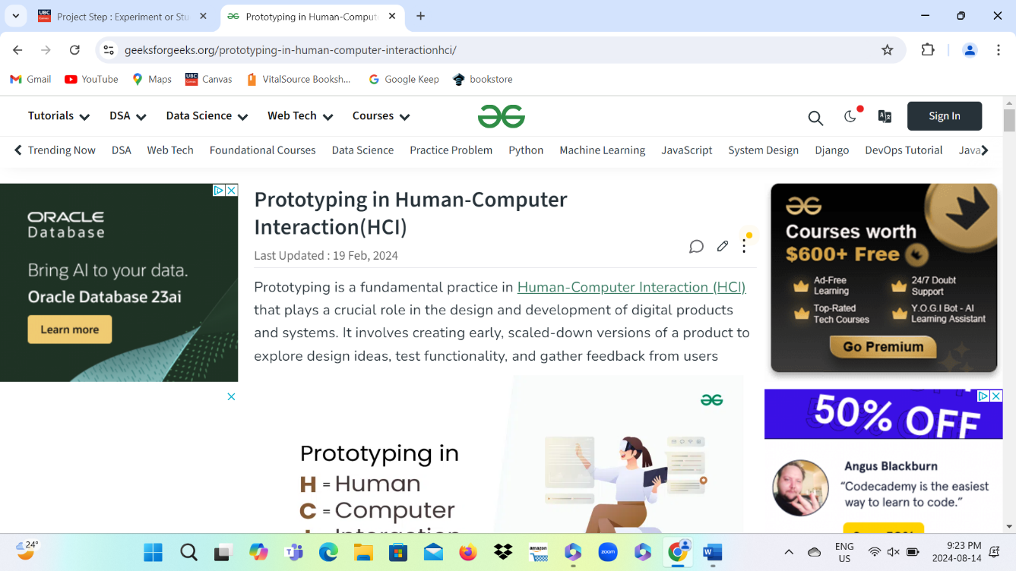

Prototyping article



Visual design article

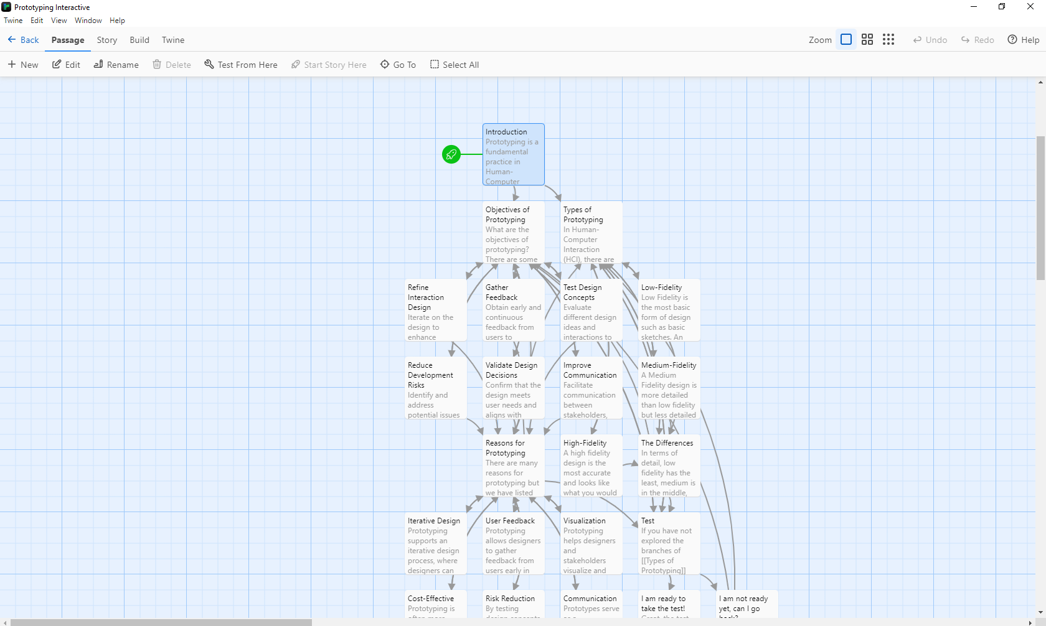

Prototyping interactive

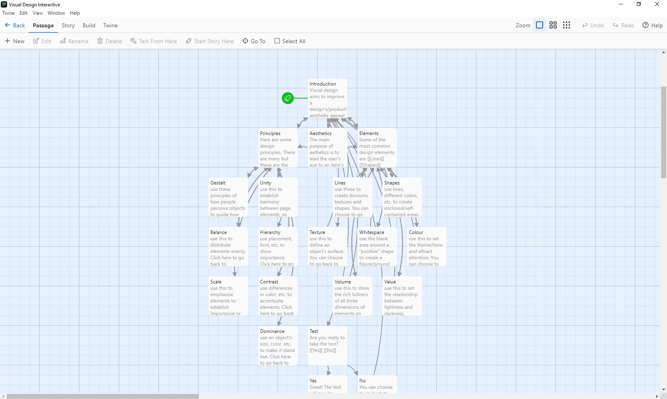

Visual design interactive

* 1. Design and dependent variables

There will be two 5 question quizzes after the interactive experience or articles. To keep the focus of the participants, they will read or engage with the shortest amount of content. This will make sure they do not lose focus or find the information to be too much to digest. The participants will be asked to engage with the article or the interactive story before being given a 5-minute break and then 10 minutes to answer the quiz questions. To make sure there is no bias, we will first have one person engage with the material at a time. This will be my mother and my father engaging with the prototyping article [6] or interactive story. After they go through the process, I will have my sister and grandfather go through the process with the visual design article [7] or interactive story. The reason for choosing these two topics is because they are short, and I found them the easiest to understand. They will be given a short explanation on HCI before all of this, this explanation will be written down in order to maintain consistency. The design type is mixed because while participants are having a unique experience with the separate material, mode of delivery combination. There are still two people who experience each form of delivery. The independent variables are whether it is interactive or not, which I will refer to as mode of delivery, and the information being presented, which I will refer to as material. One dependent variable is the knowledge retained by the participants which is measured through how many quiz questions are right or wrong. Another dependent variable is the experience of the users. Did they find the content engaging? Were they able to keep interest? How time consuming did they find it? This will be measured through the survey that will be given out after the quiz.

1. Results

In Terms of results, they look like what was predicted. For the visual design section, my grandfather read the article [7], and my sister went through the interactive. The quiz, which I developed by feeding the article into ChatGPT and asking them to generate a quiz, consisted of 5 questions and both participants took the same test. It took my grandfather less than 10 minutes to finish the article, and I then gave him the test. He ended up getting three of the five questions correct with the first two questions being answered incorrectly. In terms of the user experience survey which included five questions, he answered that he never lost focus, the task was mostly informative, mostly relevant to the quiz, barely difficult, and agreed it was an effective method of learning. My sister went through the interactive and the results show the interactive was more effective. She managed to get four out of five questions correct with her only getting the third question wrong. For the user experience survey, she said she almost never lost focus on the task, found it very informative, very relevant to the quiz, barely difficult, and strongly agreed it was an effective method of learning. Now comparing the results between the article[7] and interactive for visual design. The interactive resulted in more correct questions, despite my sister saying almost never to losing focus while my grandfather said never. The interactive was seen as very informative compared to the article’s [7] mostly relevant, very informative compared to mostly informative, very relevant compared to mostly relevant, strongly agree to agree. The only question they were the same on was difficulty of the task which both said barely difficult to.

For the prototyping section, I had my mother read the article [6] and father go through the interactive. Same as my grandfather, my mother managed to get three of the five questions correct, getting questions two and four wrong. In terms of user experience survey, she said she lost focus sometimes, found the task barely informative, somewhat relevant to the quiz, somewhat difficult, and agreed it was an effective method of learning. Similarly to my sister, my father performed better on the quiz, getting all five questions correct. He also found the task mostly informative, almost never lost focus, found the information very relevant to the quiz, somewhat difficult, and strongly agreed it was an effective method of learning. Again, the interactive preformed better on survey questions one, two, three, and five. Question four was the same for both, but there was not a question where the article outperformed the interactive. This is different from the visual design section where the article [7] outperformed the interactive on question one. This time there is a larger difference between the quiz answers. The interactive lead to all the questions being right here while the article [6], once again, led to only three correct answers.

In terms of gathering data, the only issue was getting everyone free at the same time. My sister and grandfather are available all day, but I have to wait for my parents to get off work. This becomes a larger problem because my mother often works different shifts, making the process even more difficult. This is why I had to wait for a day where everyone would be home at the same day and make the time to collect the data. Collecting the data, did not take much time as reading the article took less than 10 minutes for each reader and the interactive took around 5 minutes for both as well. Other than this, there were no data gathering problems.

The analysis was done by checking the quiz answers and looking at the survey responses. The mean result of the prototyping section is (3+5)/2 = 4/5 while the mean result of the visual design section is (3+4)/2 = 3.5/5. This means there is a 0.5 difference between the two sections, which is within standard deviation. The mean result of articles is 3/5, since they both had the same number of correct questions. The mean result of the interactives is (4+5)/2 = 4.5/5 which is 1.5 points higher, meaning it not within standard deviation. The standard deviation is ((3-3.75)^2 + (3-3.75)^2 + (4-3.75)^2 + (5-3.75)^2)/4 = 0.8. This is of all the test results. The mean of all test results is (4+3+3+5)/4 = 3.75. This means that the mean of the articles is below the mean of all the results while the mean of the interactives is above this mean. This shows that the interactive is more effective than the articles is terms of correct test questions. In terms of the survey answers, we will consider a scale of 1 to 5, with 5 being the most desirable and 1 being the least. This is because the questions all have 5 possible answers. For my father we have 4, 4, 5, 3, 5, giving him a score of 21. My mother has 3, 2, 3, 3, 4, giving her a score of 15. So, for the prototyping section, the interactive has a 6-point higher user rating than the article. My sister has 4, 5, 5, 4, 5, giving her a score of 23. My grandfather has 5, 4, 3, 4, 4, giving him a score of 20. This means the interactive has a 3-point higher user rating for the visual design section. Together, the article readers have a score of 35 while the interactive users have a score of 44, meaning the interactive user’s combined score is 9 points higher. This shows that the interactives give a better user experience than the articles.

* 1. Pictures

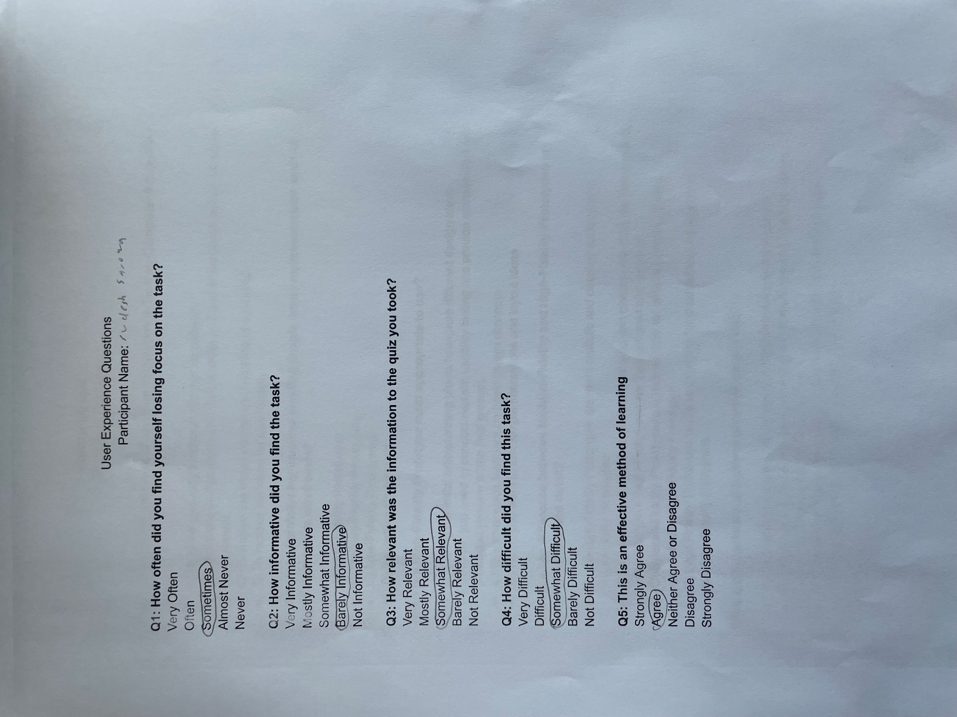

Mother survey

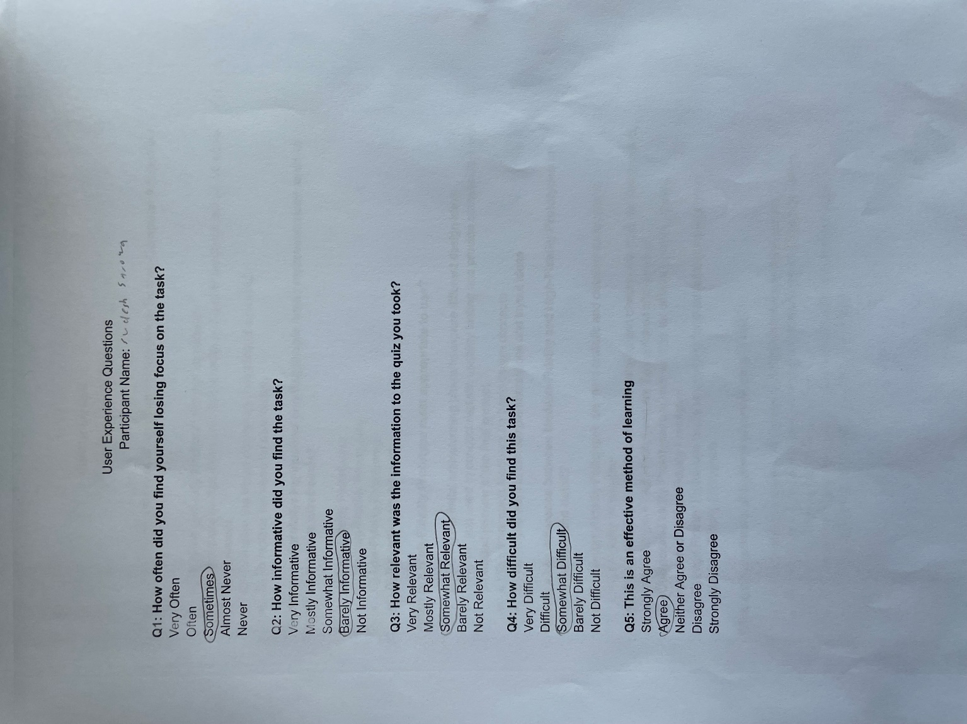

Mother quiz

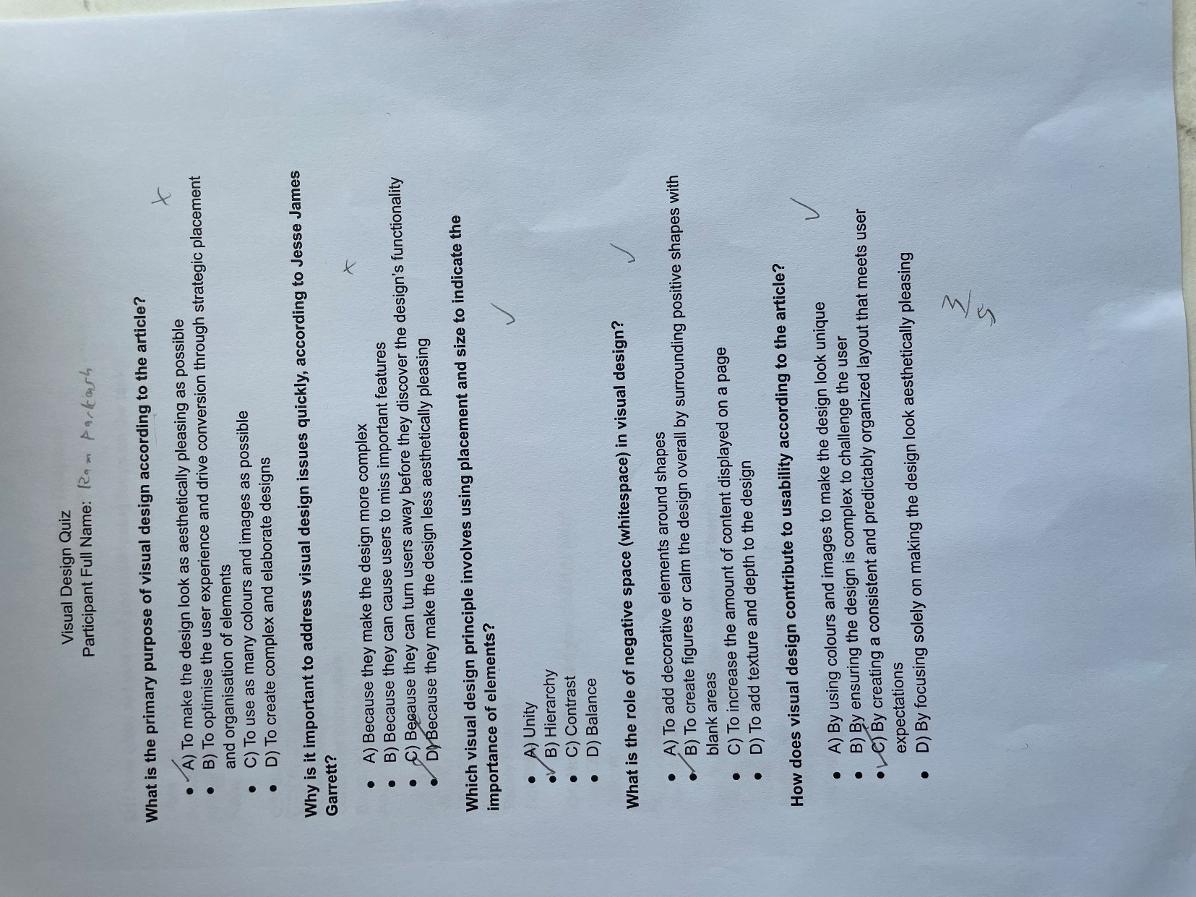

Grandfather quiz

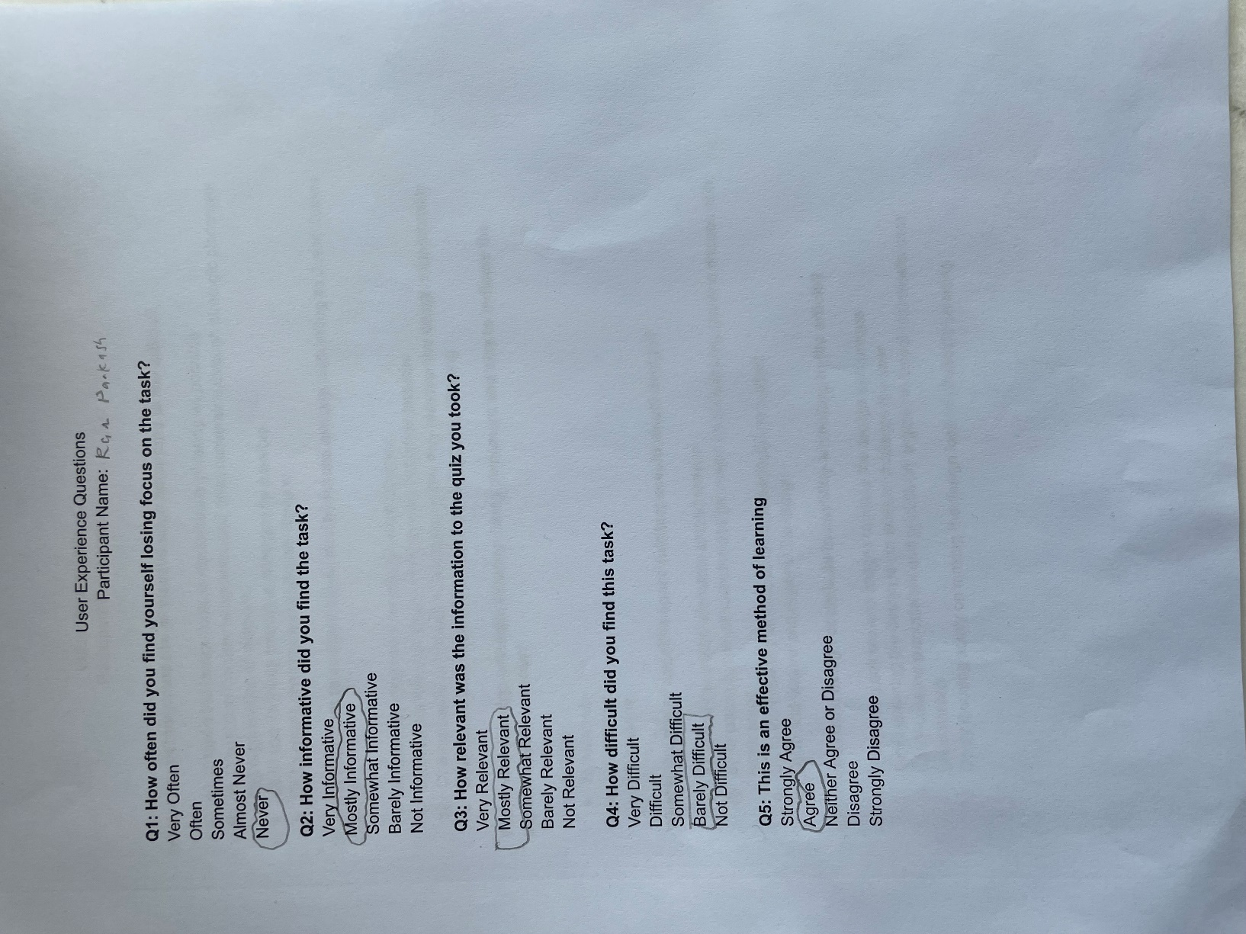

Grandfather survey

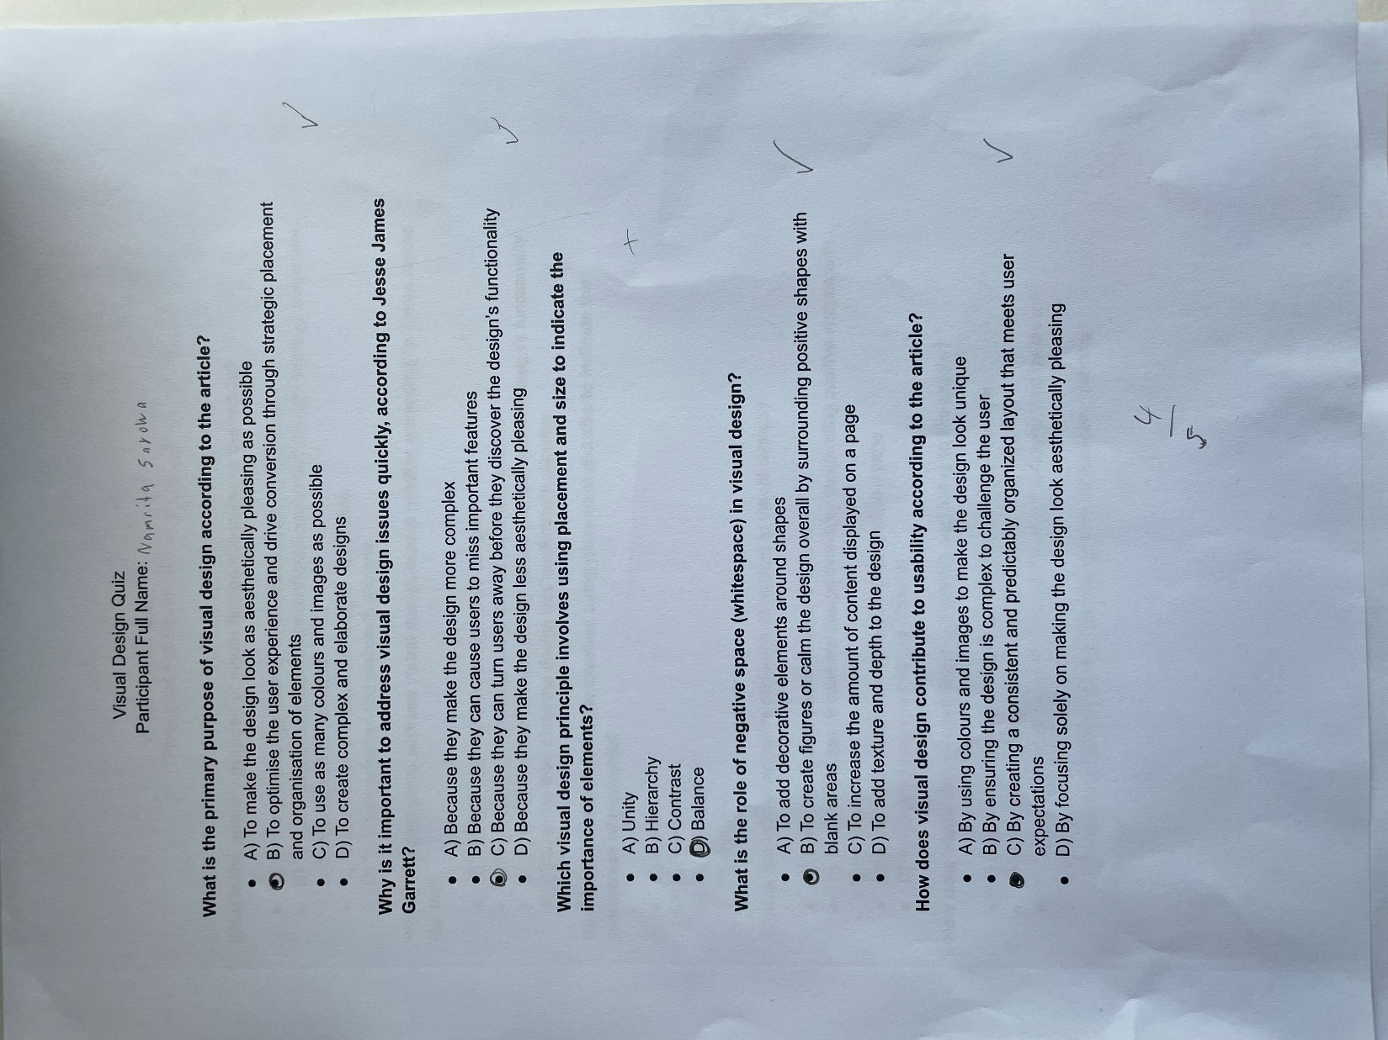

Sister quiz

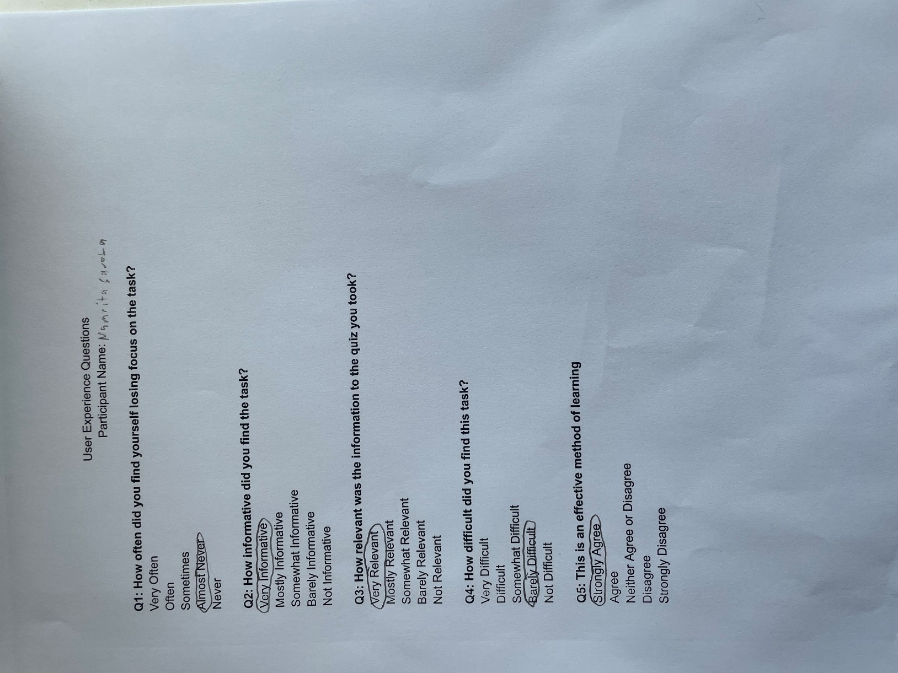

Sister survey

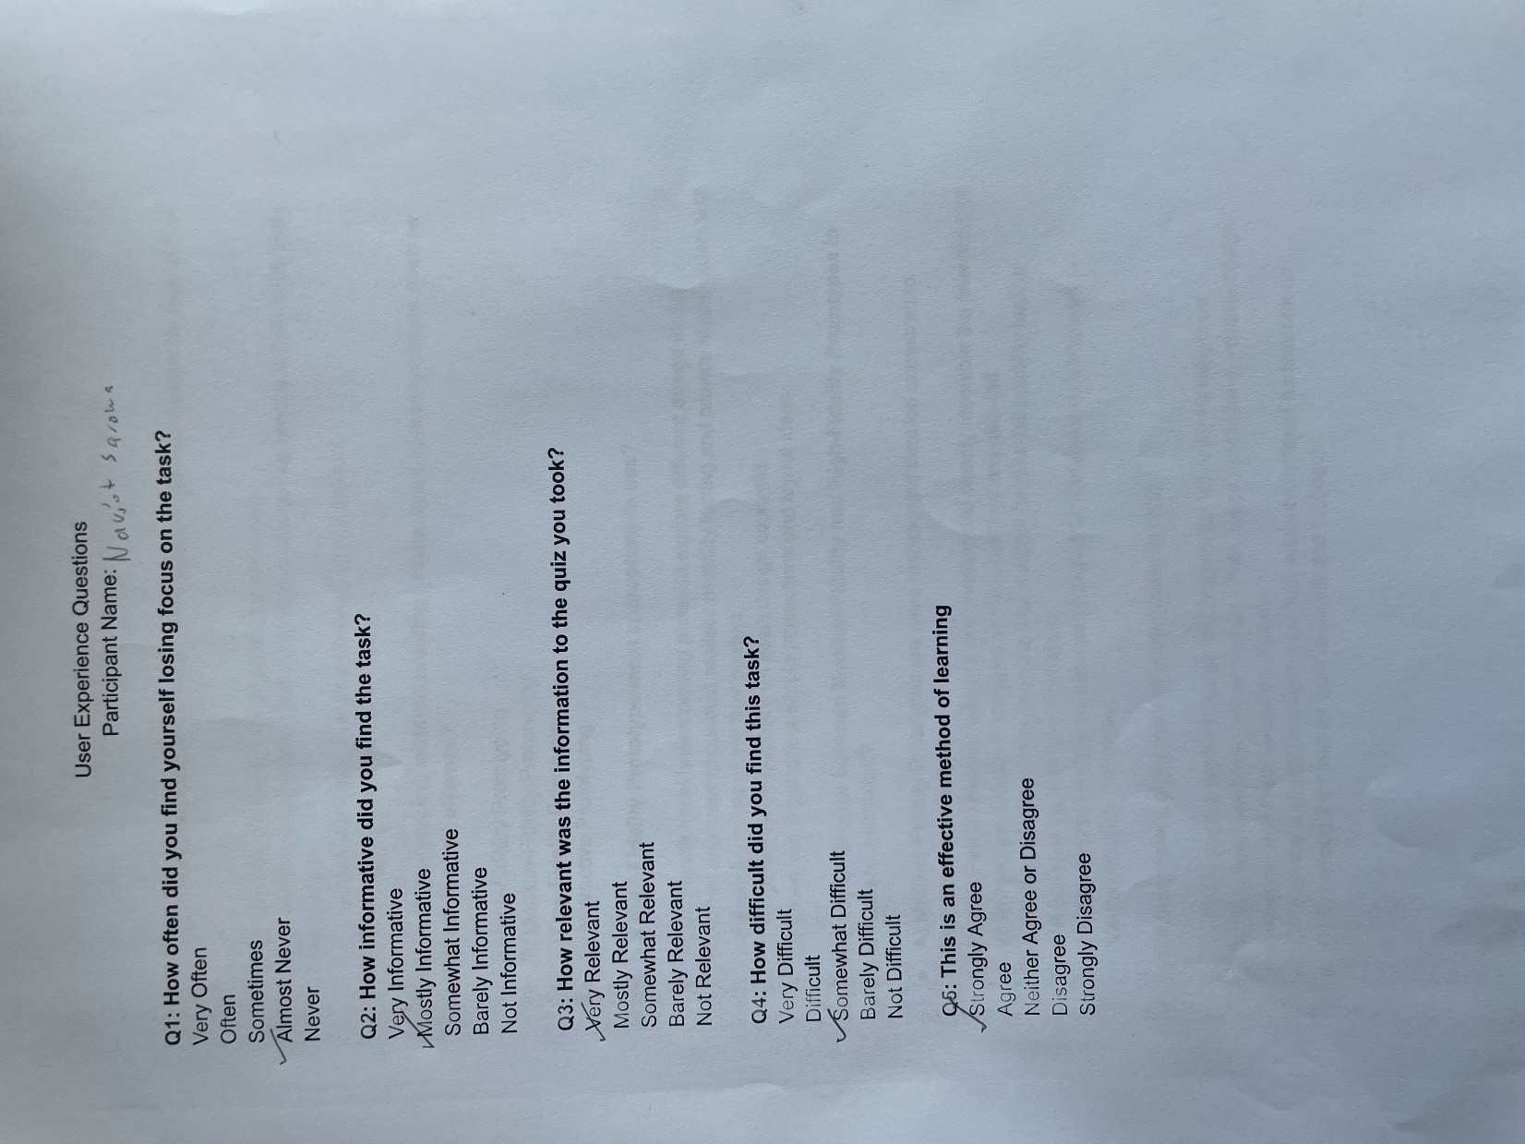

Father quiz

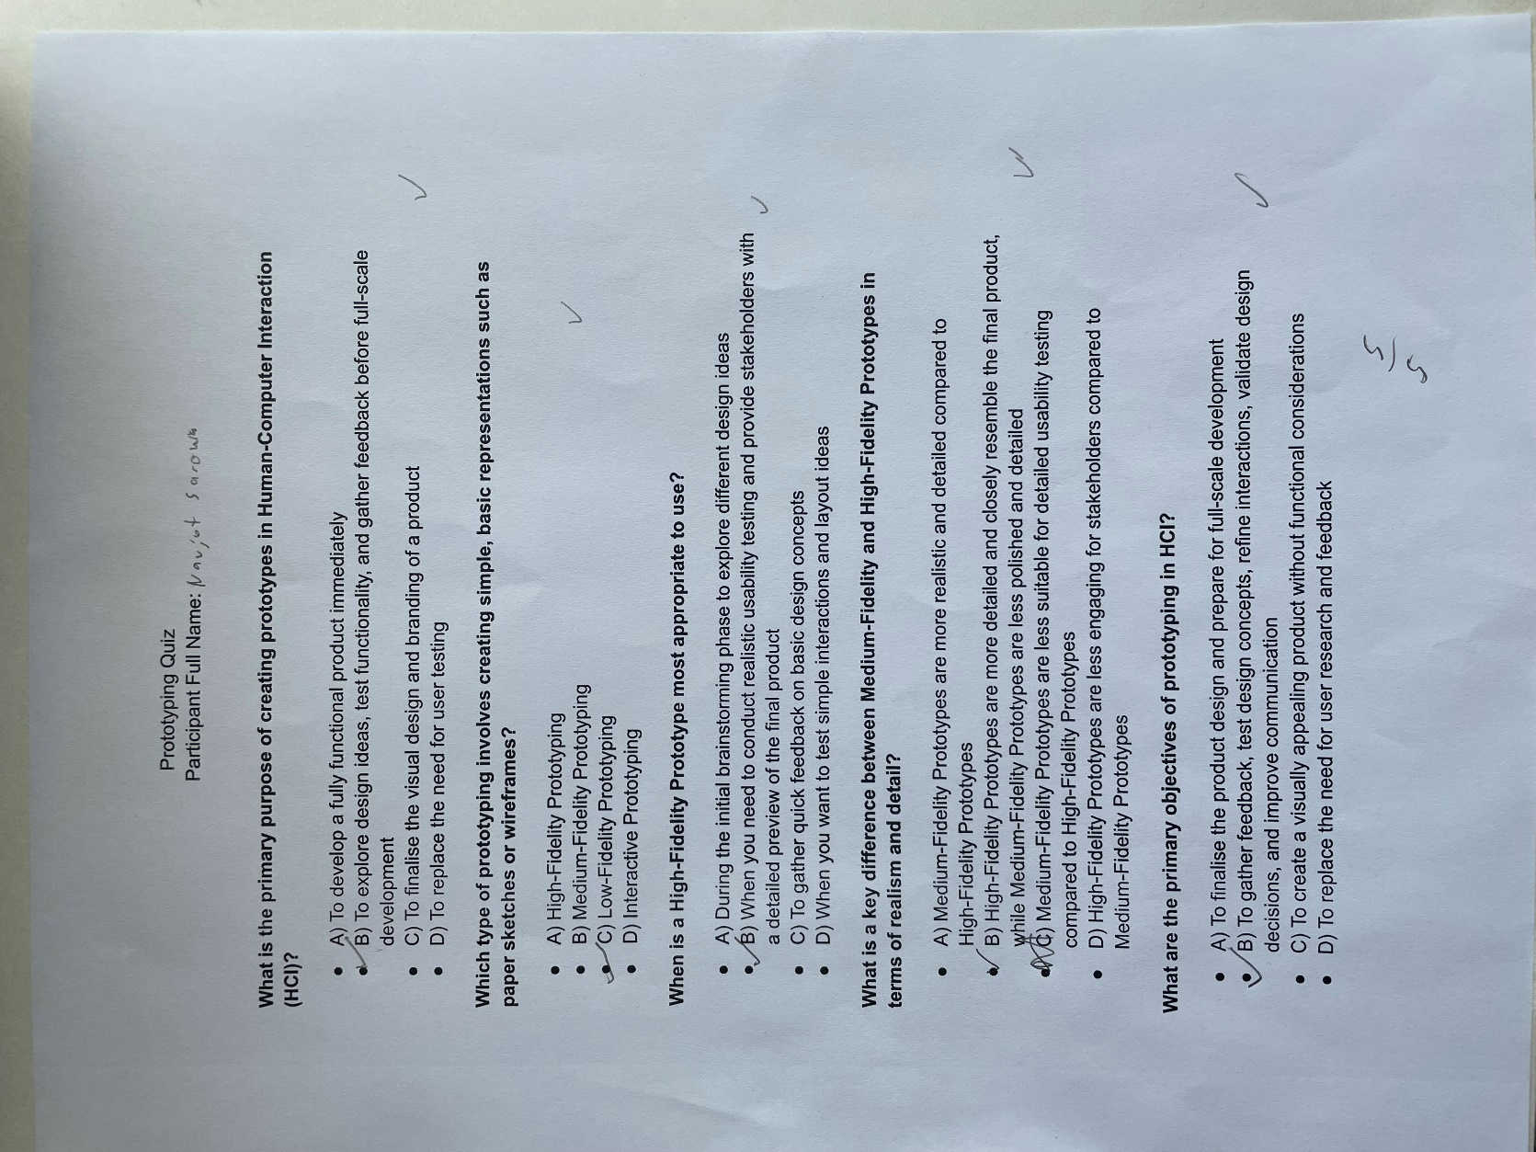

Father survey

* 1. Interactive screenshots
     1. Prototyping interactive

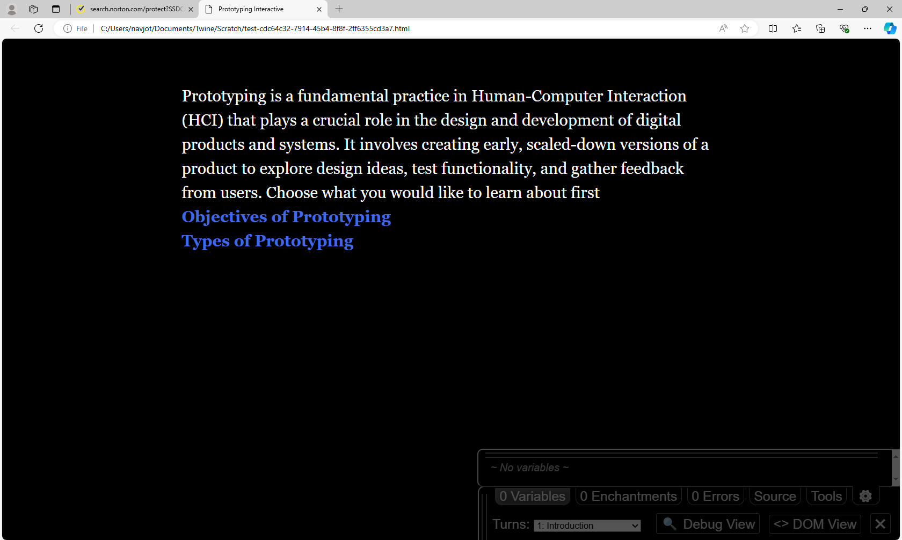

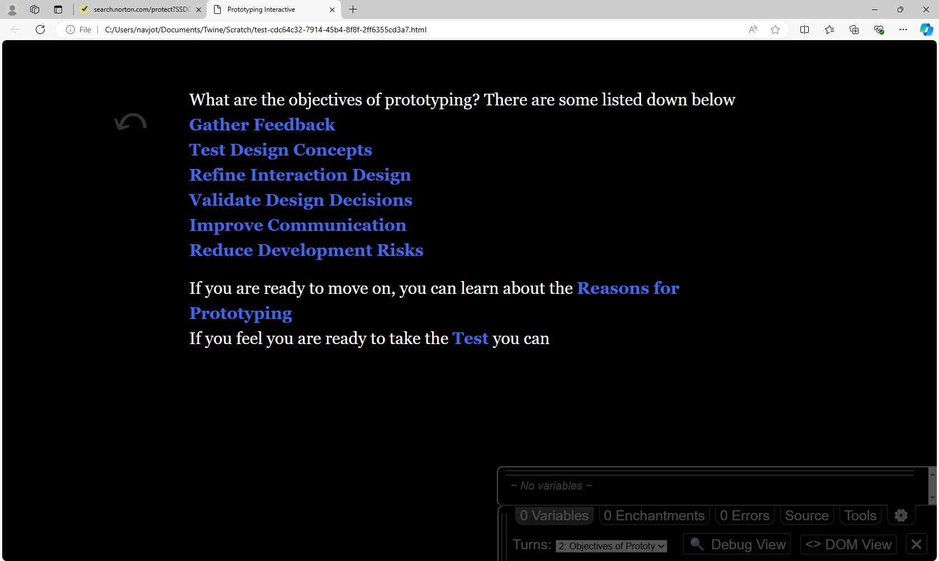

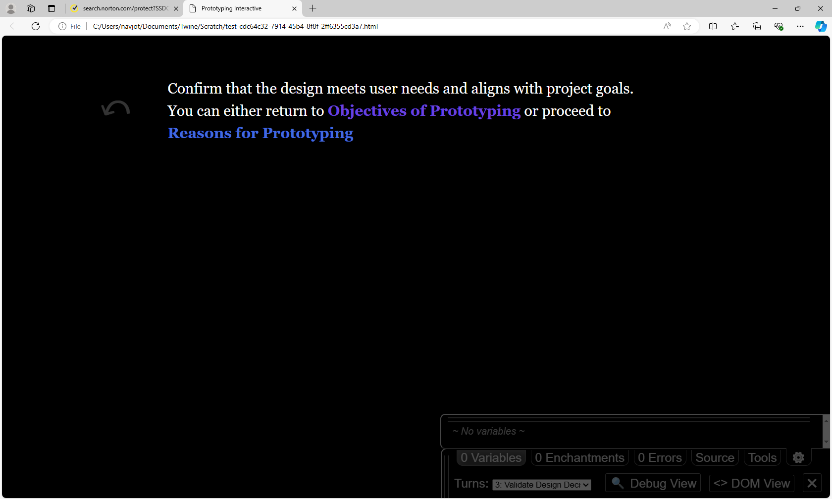

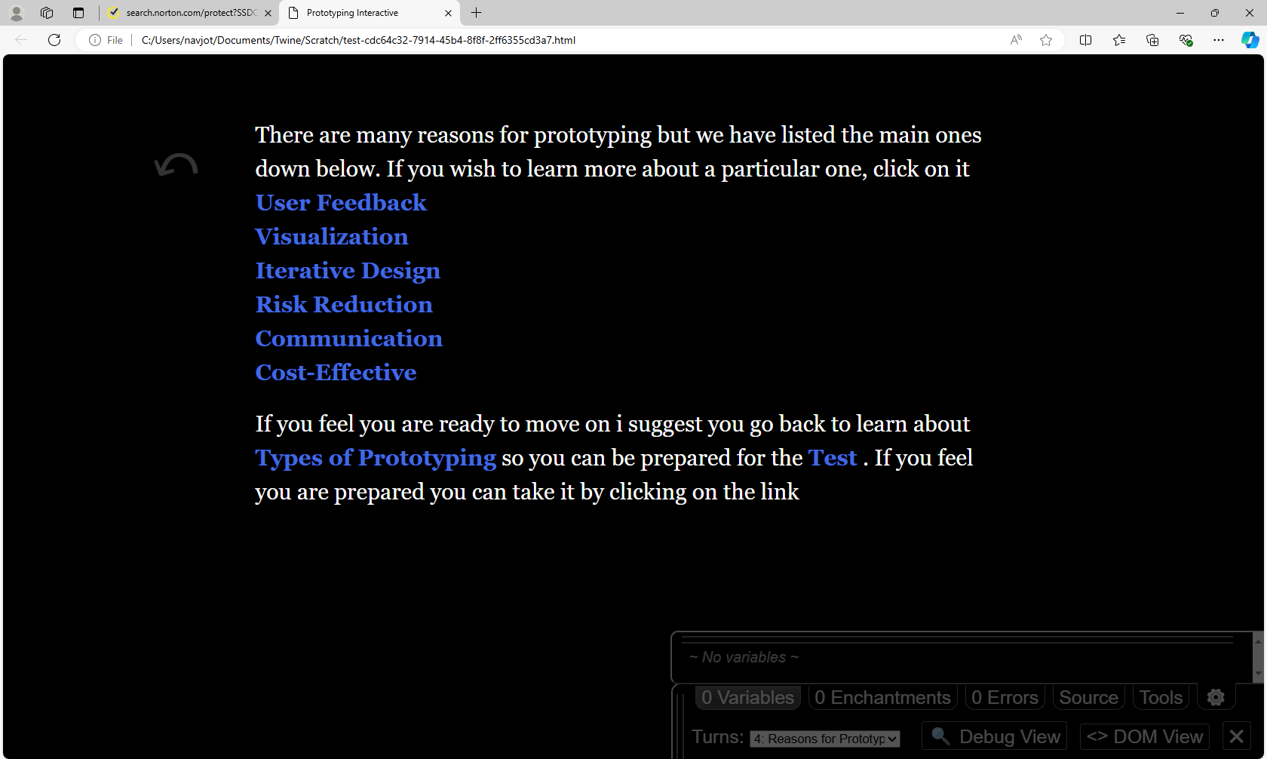

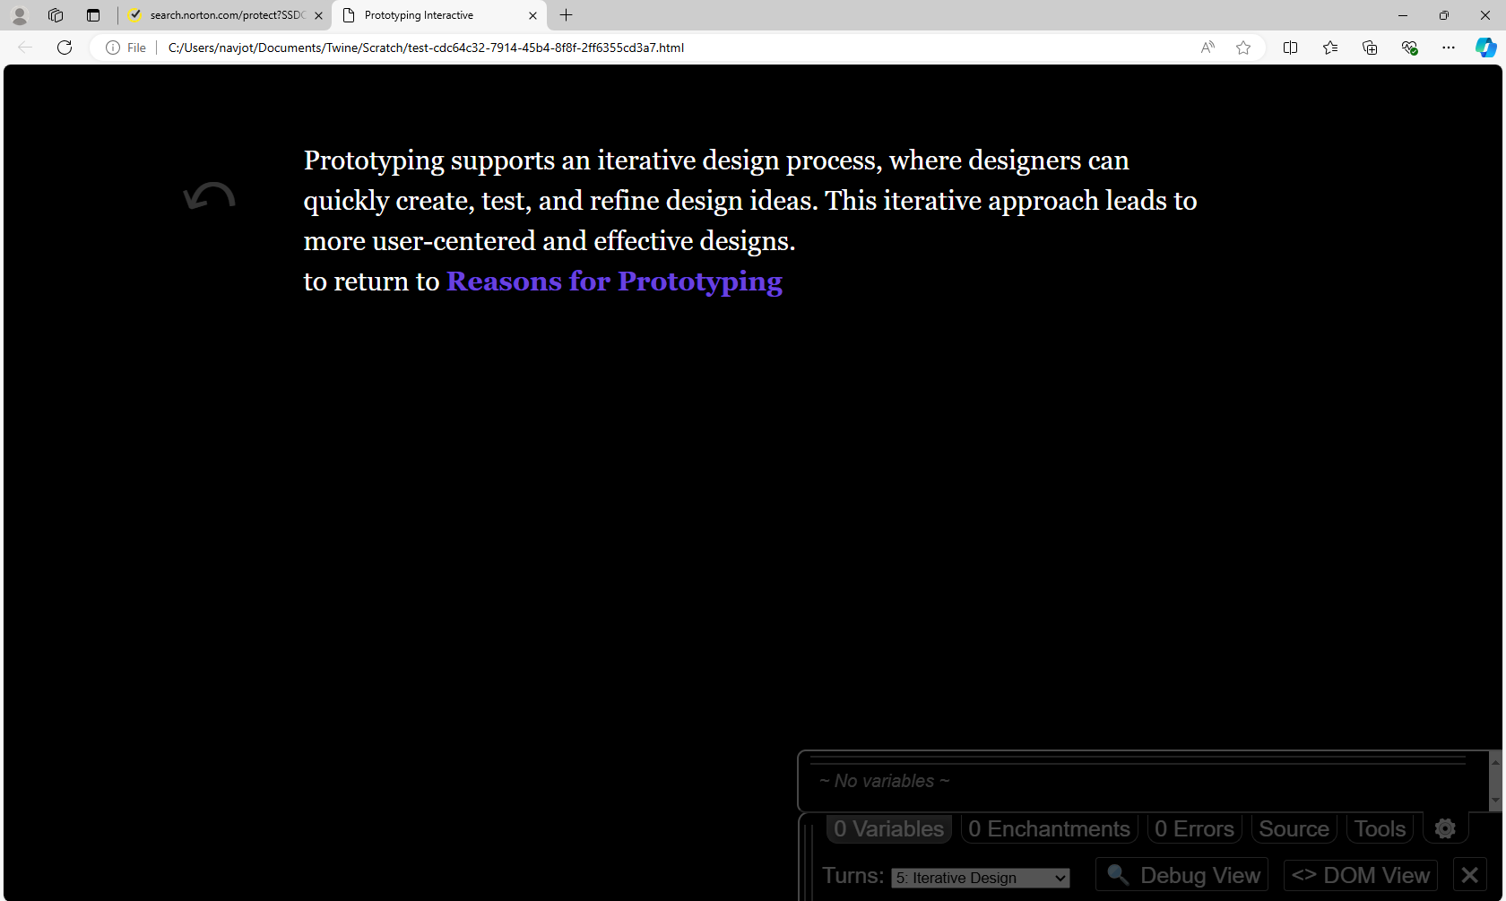

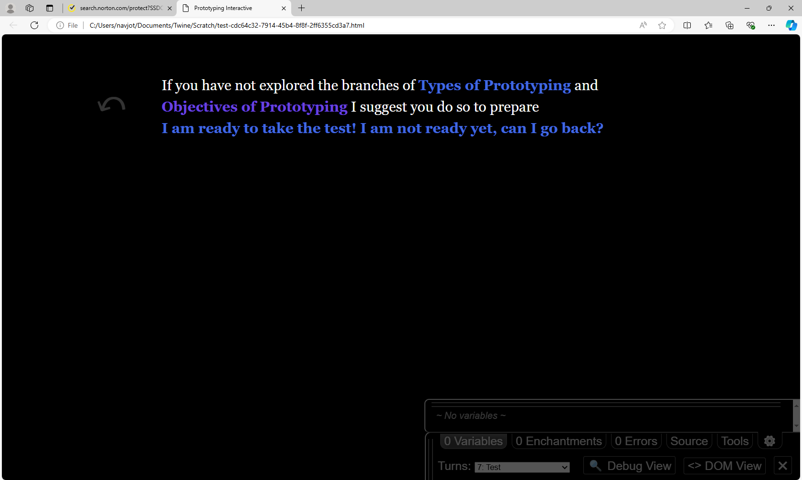

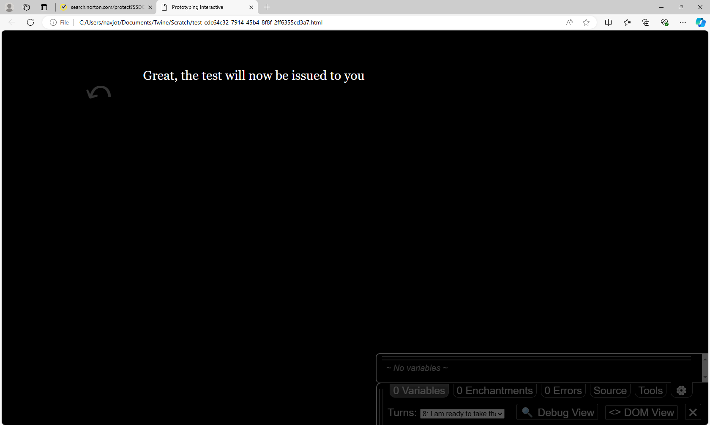

* + 1. Visual design interactive

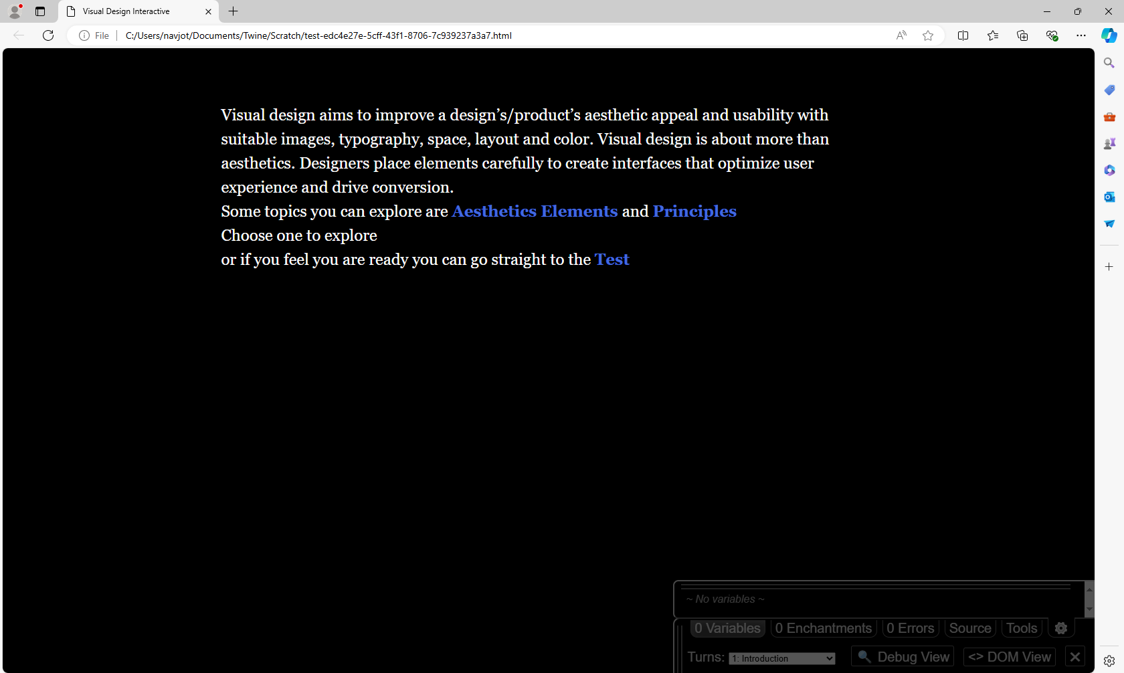

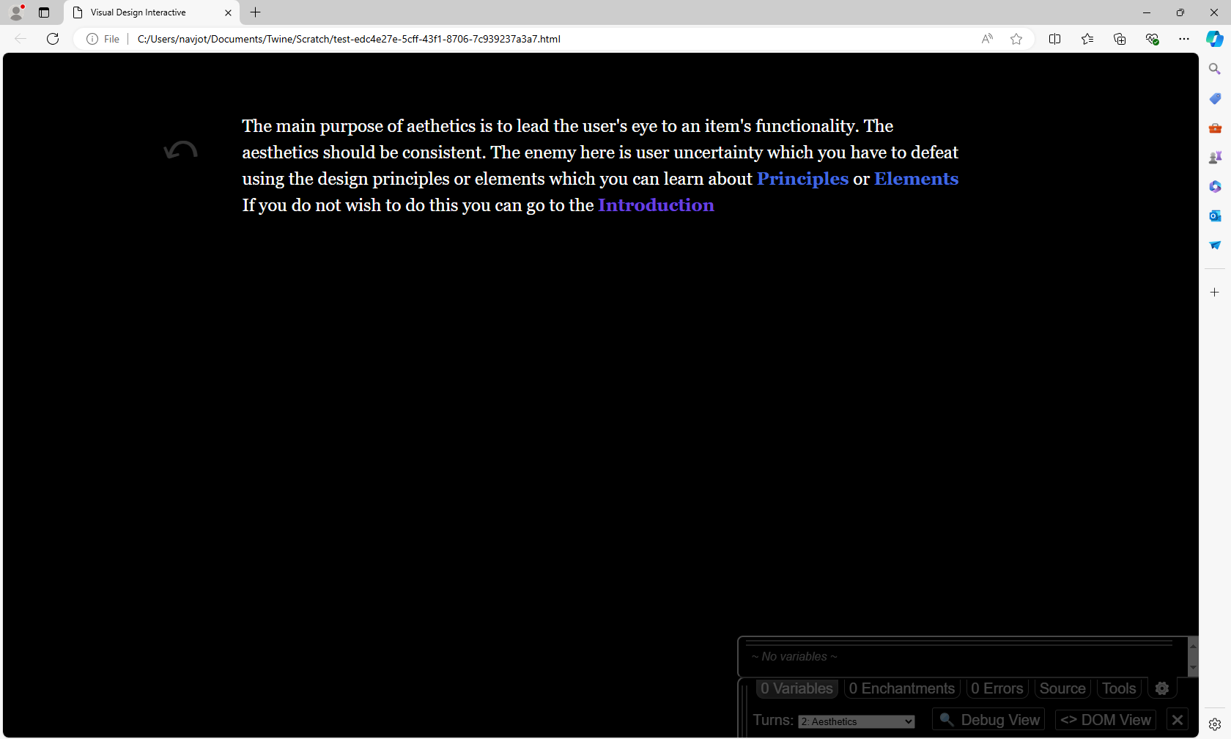

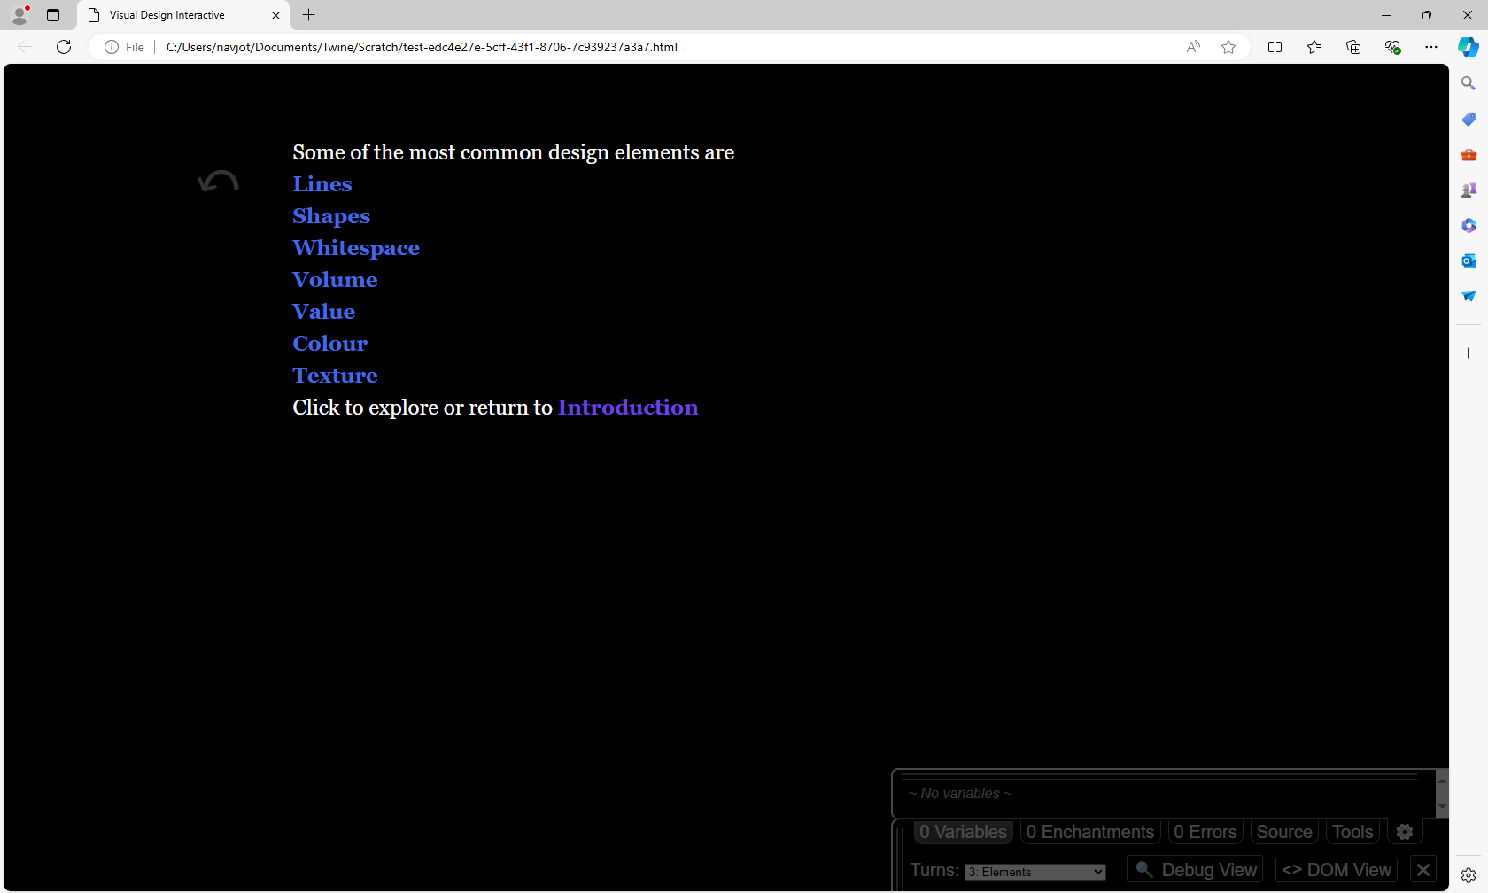

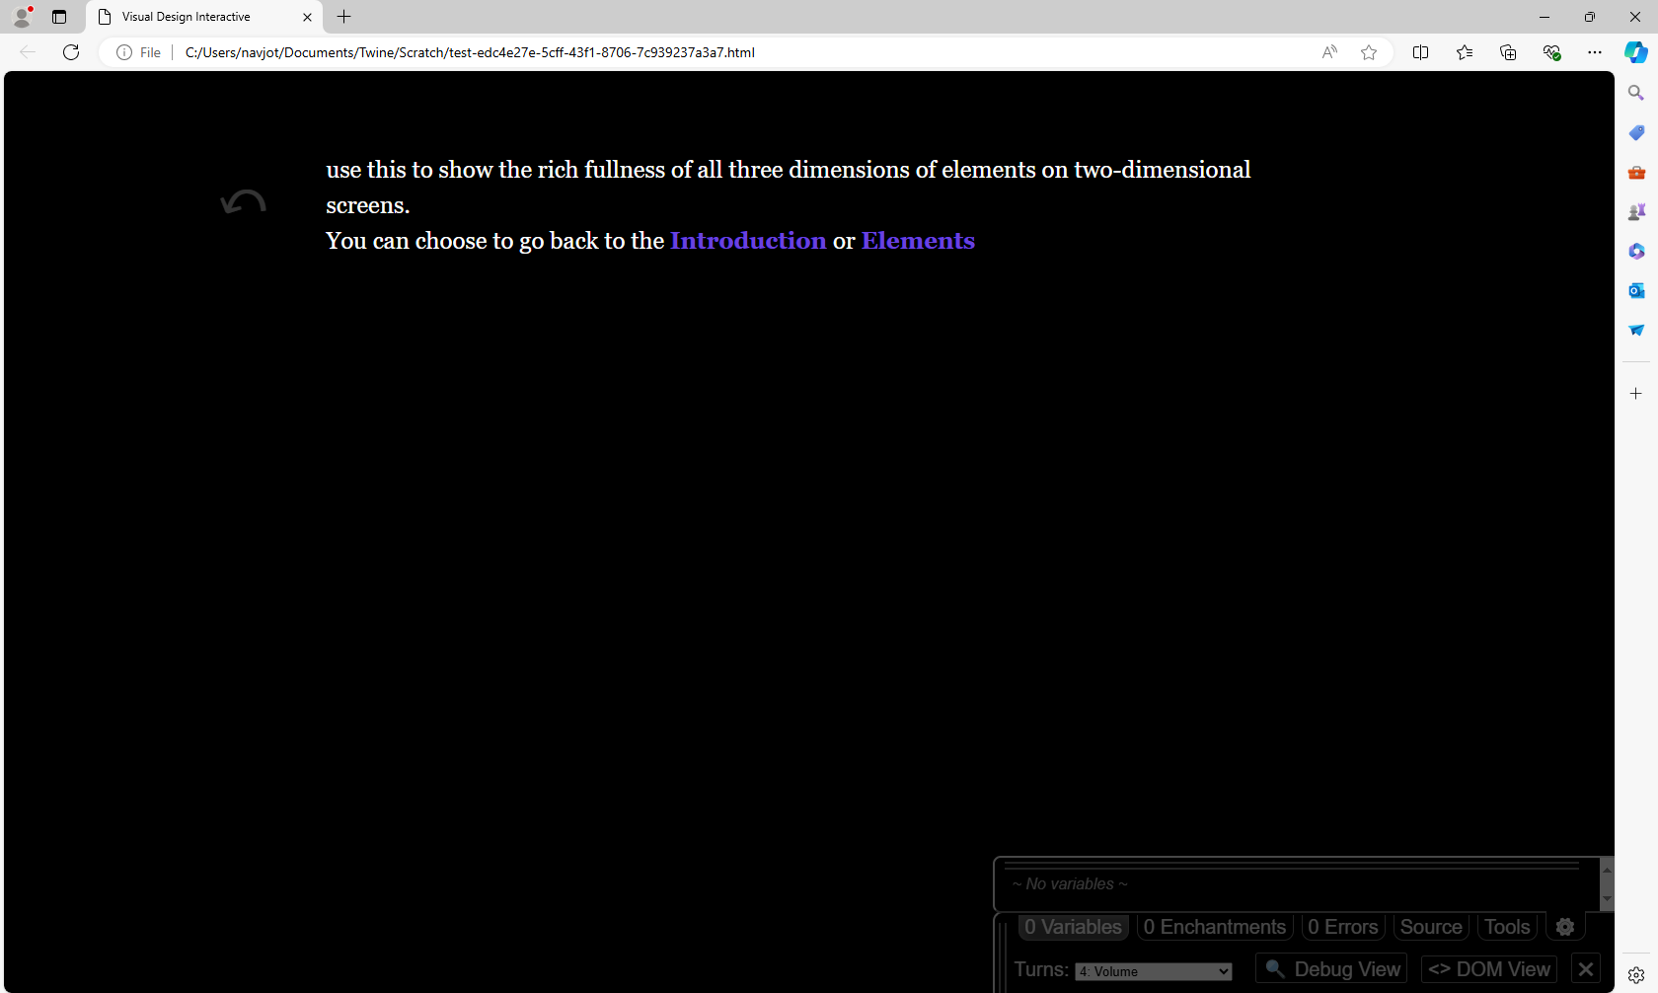

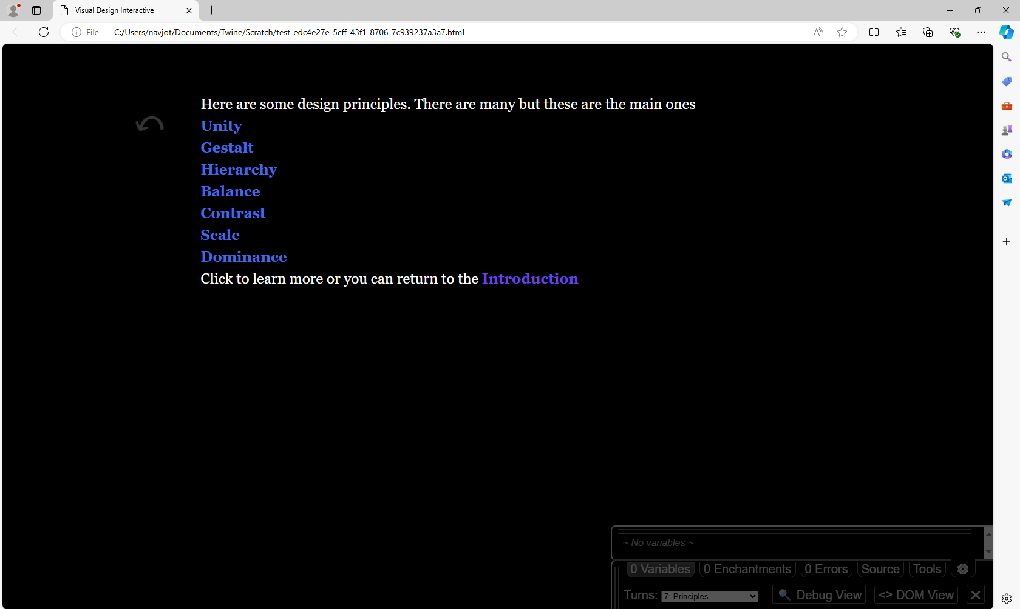



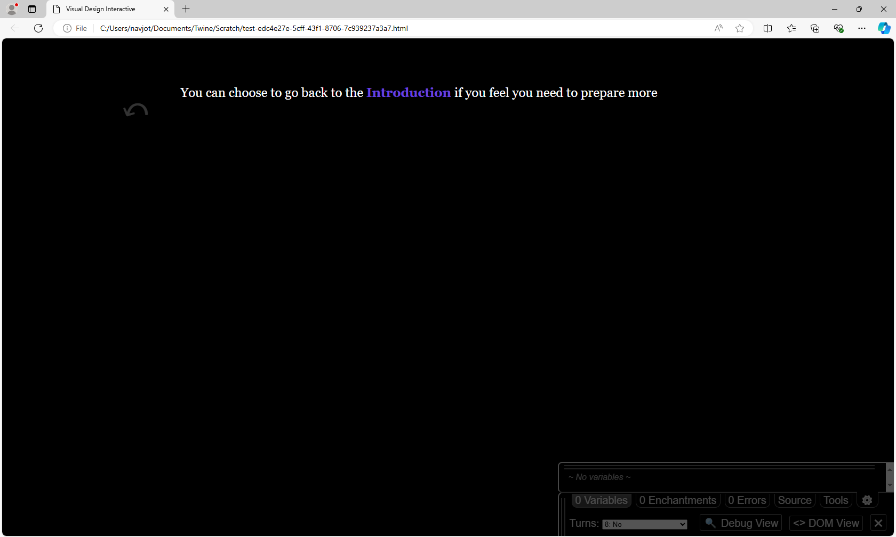

1. discussion

What can we do with these results and what further research can be done? This was a very small sample size of only four people so there is not much that can be determined but it does lay the groundwork for further research. There is also the problem that I had not created an interactive story type design before this, so inexperience is also a factor. Since the results were what we were expecting, we can determine our hypothesis was correct and we made sure to control for outside factors. One thing we were limited by, was my knowledge of the topics. Despite taking a class where these were topics, I am not an expect. This limitation was mitigated with the interactives being based on the articles. For future design, websites meant for computer science education, that are meant for the average person, could adopt elements of interactive learning. A larger study could be conducted to see if the results are replicated with a larger sample size and more time.

1. Conclusion

We compared interactive and non-interactive methods of learning in regards to computer science topics and non-computer science people. This was to learn how computer science education can be made more immersive for the general public. The non-interactive involved participants reading an article and interactive involved participants going through an interactive experience. We measured the participants understanding through a five-question quiz and their experience through a five-question survey. This was done for two topics, prototyping and visual design. These are topics from the human computer interactive class at the University of British Columbia Okanagan. In terms of the quiz and survey, the interactive outperformed the non-interactive. Further reason might include a large-scale study with more participants, larger quizzes, improved survey questions, and more funding. In order to further our knowledge, we must test our limitations.

1. References

[1] Ferreira, Marta, et al. “Interacting with Climate Change: A Survey of HCI and Design Projects and Their Use of Transmedia Storytelling.” *SpringerLink*, Springer International Publishing, 1 Jan. 1970, link.springer.com/chapter/10.1007/978-3-030-92300-6_33.

[2] “What Is Interactive Storytelling and How to Improve Your Storytelling.” *uStory*, ustory.app/en/ustorier/what-is-interactive-storytelling-and-how-to-improve-your-storytelling#:~:text=An%20interactive%20story%20is%20a,attention%20again%20in%20recent%20years. Accessed 6 Aug. 2024.

[3] Nair, Viknesh, and Melor Md Yunus. “A Systematic Review of Digital Storytelling in Improving Speaking Skills.” *MDPI*, Multidisciplinary Digital Publishing Institute, 1 Sept. 2021, www.mdpi.com/2071-1050/13/17/9829.

[4] “What Is Human-Computer Interaction (HCI)?” *The Interaction Design Foundation*, Interaction Design Foundation, 5 Apr. 2024, www.interaction-design.org/literature/topics/human-computer-interaction#:~:text=Human%2Dcomputer%20interaction%20(HCI)%20is%20a%20multidisciplinary%20field%20of,forms%20of%20information%20technology%20design.

[5] Melcer, Edward F., et al. “Teaching Responsible Conduct of Research through an Interactive Storytelling Game: Extended Abstracts of the 2020 Chi Conference on Human Factors in Computing Systems.” *ACM Conferences*, 25 Apr. 2020, dl.acm.org/doi/abs/10.1145/3334480.3382973.

[6] “Prototyping in Human-Computer Interaction(Hci).” *GeeksforGeeks*, GeeksforGeeks, 19 Feb. 2024, [www.geeksforgeeks.org/prototyping-in-human-computer-interactionhci/](http://www.geeksforgeeks.org/prototyping-in-human-computer-interactionhci/).

[7] Interaction Design Foundation - IxDF. “What is Visual Design?” Interaction Design Foundation - IxDF. 9 Aug. 2024 https://www.interaction-design.org/literature/topics/visual-design​